Thursday 4th May 2023

Re: Year 5 Secondary Transfer Meeting

Dear Year 5 Parents and Carers,

I hope you had a relaxing Bank Holiday weekend with your children.

We would like to invite all Year 5 parents to an important secondary transfer meeting in the school hall on Monday 15th May from 5:00-5:30pm. As we quickly approach the end of the academic school year, this meeting will cover the following transition arrangements for your child over the forthcoming weeks and months:

- Selection test application process and information
- How to apply for a secondary school place
- Banding tests
- Offers of places
- Timetable of key dates

Mr Poole will be leading the meeting supported by Ms Brewer and Miss Michael who will also be available to support with any questions you may have about your child regarding this process.

We look forward to seeing you on Monday 15th May.

Best wishes,

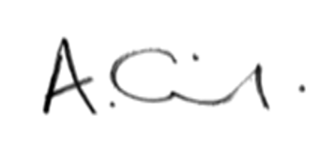

Mrs Oldfield
Headteacher

