 |  |  |  |  | Year 1- Autumn 1  Topic Overview –  In Autumn 1, students will begin to get an understanding of the local area, looking at very basic physical and human features of the surrounding area. Following that, the students will use maps to explore the United Kingdom. This is a unit of study that sets a basic geographic knowledge and will explore the local area, including where we live. We will then go on to explore the UK.
 |  |  |  |  | Big Bang! In Year 1, we will be reading a variety of fairy tales inspired or focussed on traditional tales. We will create lots of fairy tale inspired art and work and investigate them in many forms.
Our Learning Overview
Key Texts

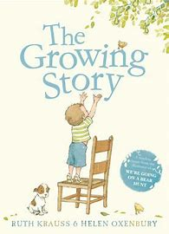
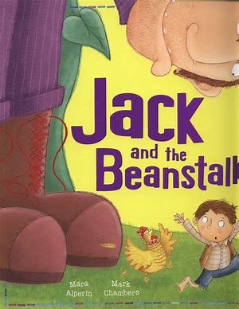
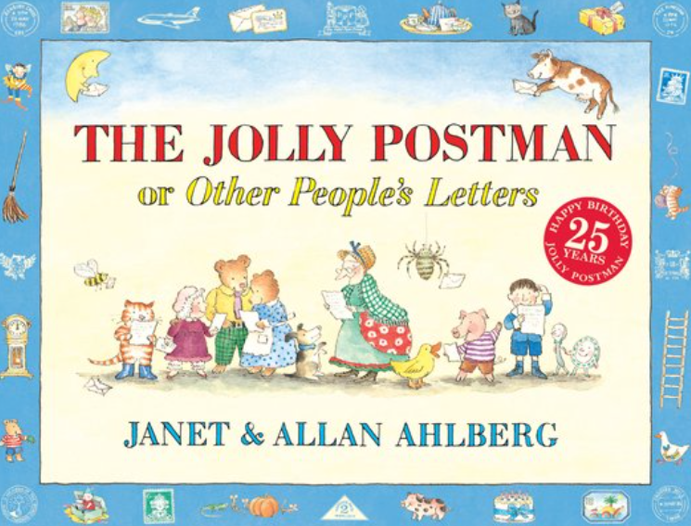

 |  |  |  | English |  |  | In Writing, we will be revisiting traditional tales, such as Goldilocks and the Three Bears; Jack and the Beanstalk. The children will be exploring alternative versions of popular stories.
 |  |  |  | Maths |  |  | In Maths, we will be consolidating our place value knowledge, continuing to develop our addition and subtraction skills.
 | Once Upon a Time |  |  | Science |  |  | In Science, we will be learning about plants. We will learn about the features of a plant and about different types of trees2.
 |  |  |  | Geography |  |  | In Geography, we will use maps to identify the four countries and capitals of the United Kingdom, as well as its surrounding seas. We will also be looking at the oceans and seas that surround us.
 |  |  |  | Art/DT |  |  | In Art our focus is painting. We will develop skills to allow us to use paint effectively and learn about primary and secondary colours.
 |  |  |  | PSHE/RE |  |  | In RE, we will be learning different religious stories with a focus on Christianity and sharing stories to explain how Christians think of God.
 |  |  |  | Music |  |  | In Music, we will be taught to sing and play music with increasing confidence and control. We will develop an understanding of musical composition, organising and manipulating ideas within musical structures and reproducing sounds from aural memory.

