Tuesday 10th January 2023

Dear Y5 Parents and Carers,

This term, our science topic is ‘Space’. We are excited to inform you that we have arranged an onsite planetarium experience for the children that will take place in our school hall on Thursday 2nd February.

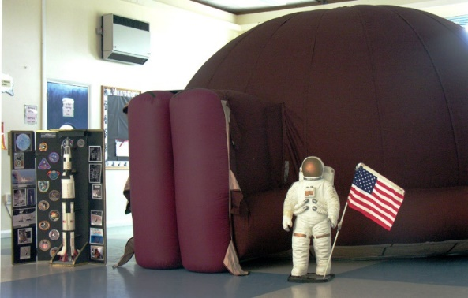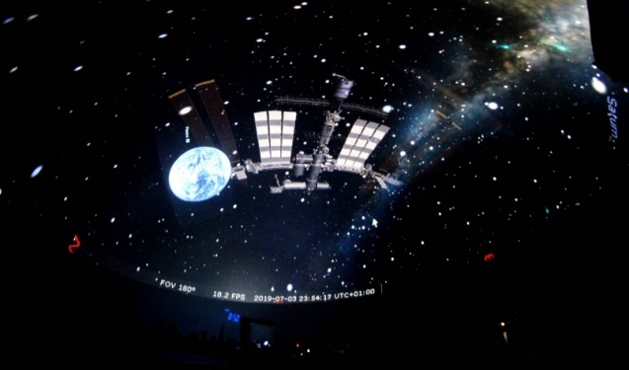

We are asking for a voluntary contribution of £3.00 per child to cover the cost of hiring the equipment and the interactive workshop - to be led by a visiting scientist.

As we are a cashless school, please pay via Arbor. You may pay the cost in smaller instalments e.g. £1.00 a week if you wish to.

This will be an immersive and memorable learning experience for the children, and we are really looking forward to the session as part of our science learning journey.

Thank you for your ongoing support.

Kind regards,

Miss Michael & Ms Brewer
Year 5 Class Teachers

