 | Reception Summer 2– Reach for the Stars  Topic Overview  In the summer term, children in Reception will grow to be confident explorers, reflecting on how they have grown since September and their journey through Reception. We will be focusing on transition into new classes in preparation for Year 1 – Reception will also haves an end of year graduation.
 | Hook Day!  Children will come into school and have a range of different fun activities linked to our core text – Kalamatas kitchen, such as dancing, painting, predicting and exploring! | Visitors –  We will be having a special visitor who will be teaching us all about Henna and showing us how it is done.  We will also learn about Bollywood dancing from a special visitor.
Our Learning Overview
My Community  Literacy  In Summer 2, Reception will continue to focus on letter recognition, and writing for different purposes. Reception will consolidate the phase 3 and 4 sounds, blending and segmenting CVC words and CVVC words. They will also be learning longer words and compound words.  Maths  We will be exploring numbers within 20, doubling and halving, weighing, length and volume. The children will be consolidating their learning this half term. Reception will be using their prior knowledge to support their new learning.  Understanding the world  Reception will be exploring different cultures around the world, especially focusing on India. We will be covering this through our core text and through our weekly shared book for the first three weeks; this will link to our art week, where we will explore culture in India in more depth.  Communication and language  Within our continuous provision, children will have the opportunity to use talk and develop their vocabulary. They will be focusing on retelling stories orally and use this within their play as well as retelling facts and stories.  Expressive arts and design  During this half term, Reception children will have the opportunity to manipulate materials for a planned effect. They will also be encouraged to join in with songs and learn through rhymes. Children will explore and create stories around their learning and use available props to support role play. Our children will have the opportunity to make models using different materials.  PSED  Children will continue to demonstrate friendly behaviour, initiate conversations, and consolidate good relationships with peers and adults. Reception will continue to understand and follow behaviour expectations in the classroom. To support with the transition into new classes in readiness for Year 1, children will develop confidence when talking to other children when playing, Children will also be learning to talk confidently during carpet sessions.  Physical development  We will be continuing our focus with fine motor skills and gross motor skills and getting into practice for Sports day. |  |  | Key Texts  Our core text -  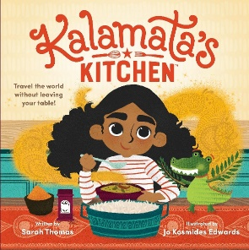  Art and diversity –  within this fortnight, we will be learning all about the Indian culture; we will get our inspiration from the artist – Marla Olmstead. We will have lots of artist fun including having our own Holi fest.

