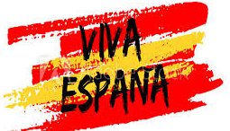 | Year 3 Autumn 1 –Viva Espana!  Topic Overview  In Autumn 1 the children will be comparing the lives of those who live in Spain and those who live in the UK. The children will learn about the differences in climates both Spain and across different parts of the world. They will learn map skills, such as using compasses and grid references. The children will be immersed in Spanish culture, learning about different locations in Spain but specifically focussing upon Barcelona.
 | Big Bang on Monday 12th September 2022! We will find out about the Spanish language, food and culture! | Educational visit:  N/A
Our Learning Overview
Key Texts

