Monday 27th February 2023

Re: School lunch arrangements for Tuesday 28th February 2023
Dear Parents and Carers,
Unfortunately, the school kitchen will be closed tomorrow, Tuesday 28th February, as during a routine inspection today by a gas engineer, we have been informed that our boilers require immediate attention. An engineer will be coming first thing tomorrow morning to rectify the situation; however this means that our school kitchen may be out of use for the day. Consequently, we have arranged for a set lunch of a jacket potato plus a selection of toppings to be prepared off site at Northumberland Heath Primary School and brought over to Willow Bank so children still have the option of a hot meal.
If your child usually has a school meal but would prefer to bring in a packed lunch for tomorrow only, then they are of course welcome to do so.
Please accept my apologies for the inconvenience caused. The Breakfast Club taster session for Years 3 and 4 will go ahead from 8:15am tomorrow as planned.
Thank you for your ongoing support.

Best wishes,
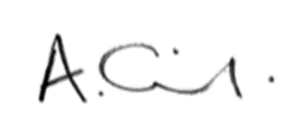
Mrs Oldfield
Headteacher

