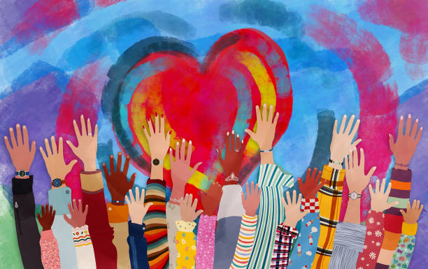 | Reception Autumn 2 – What happens in our community?  Curriculum Overview  In Autumn 2, children will look at they community that they live in, who lives there, what jobs they do and the different festivals that are celebrated.  They will explore the jobs in the local community through school visitors, stories and role play. We will share all the different festivals we celebrate at home and take part in lots of festive activities in school.
 | Hook: Our classroom will be set up for a celebration! What are we celebrating? | Trip: Magnolia will be visiting a local care home and sing carols to celebrate Christmas.
Our Learning Overview
Key Texts
