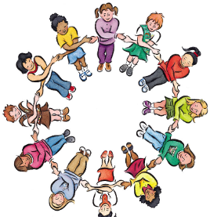 | Reception Autumn 1 – What makes you, YOU?  Topic Overview  In Autumn 1, the children will begin to learn about themselves, their families and others. This introductory topic will allow the children to explore how they are similar and different to one another, their likes and dislikes and the school rules and routines through a range of relevant texts. The children will initially be introduced to mark making and letter formation before writing CVC words and short captions.
Hook lesson
On this day we will explore the different colours in our Colour Monster story. We will learn about the primary colours, how they mix to make new colours, and create our own
Our Learning Overview |  | 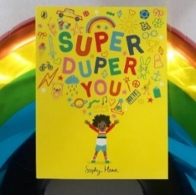  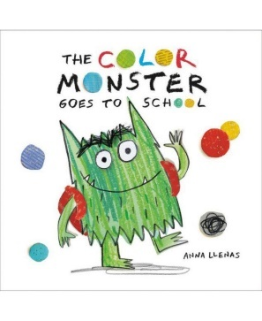  Key Texts  