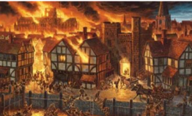 |  |  |  |  | Year 1- Autumn 2  Topic Overview – London’s Burning  In Autumn 2, students will be gripped by this significant historical event from the 17th Century! We will learn about the events which led up to the Great Fire of London, including looking at famous landmarks which were destroyed and then rebuilt. We will compare fire-safety from the past with modern day, using replica artefacts to enhance our historical enquiry. We will begin looking at primary sources, focusing on Samuel Pepys diary, which was written during the Great Fire!
 |  |  |  |  | Big Bang! Children will be investigating our own miniature fire. They will explore the environment and work out what might have occurred! They will theorise the events that took place before we explore the actual reason! |  |  |  |  | Educational visit: TBC
Our Learning Overview
Key Text

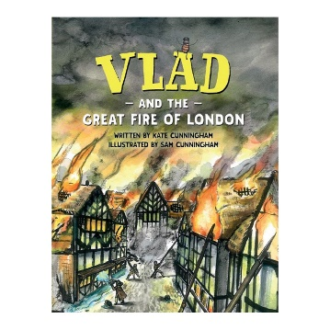

 |  |  |  | English |  |  | In Writing, we will be writing our own recounts of the Fire of London. We will also learn a model text based on ‘Vlad and the Great Fire of London’. We will innovate our model text and write our newspaper styled piece.
 |  |  |  | Maths |  |  | In Maths, we will be continuing our learning on addition and subtraction within 10. We will then move on to investigating shape and consolidating our learning on place value as well.
 | London’s Burning! |  |  | Science |  |  | In Science, we will be learning about materials. We will be observing and comparing their different properties.
 |  |  |  | History |  |  | In History, we will be learning about a major historical event- The Great Fire of London. We will learn about how it spread, the damage it caused and the changes it brought to London and Great Britain.
 |  |  |  | Art/DT |  |  | In DT, we will teach children about free standing structures and how they are built. The children will deconstruct smaller structures and identify their parts, and eventually design, make, and evaluate a product of their own.
 |  |  |  | PSHE/RE |  |  | In RE, we will be exploring celebrations including Shabbat and Eid-ul-Fitr. In the build up to Christmas, we will also revisit and perform the Nativity Story and discover what our Christmas traditions are based on.
 |  |  |  | Music |  |  | In Music, we will be looking at two new styles of music themed around Reggae and Hip-Hop music. This will be embedded through different music-based games and singing.

